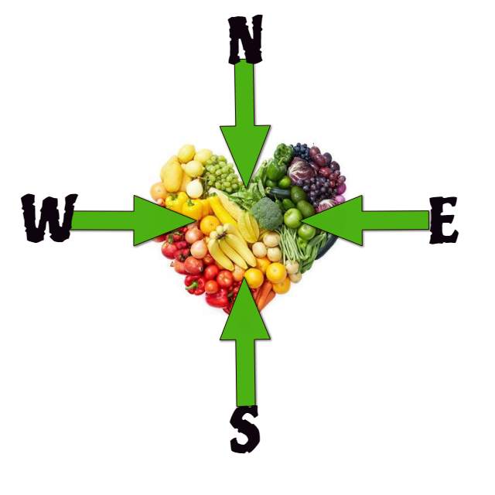
NN Sports Performance Food Diary Start Date / /
 | Monday | Tuesday | Wednesday | Thursday | Friday | Saturday | Sunday
Breakfast
Time?
Supplements?
*Energy levels ?/10
Snack
Time?
Lunch
Time?
*Energy levels ?/10
Snack
Time?
Dinner
Time?
*Energy levels ?/10
Snack
Time
Pre Training/
Match
Post Training/ Match
Hydration/ Water
* Energy Levels 1-very low 10-very high.
NN Sport Coaching Food Diaries are confidential and not shared with any Third Party. They are destroyed once recommendations have been issued. © Copyright NudeNutritionIE 2017
Please fill in as comprehensively as possible to assist us in producing accurate recommendations

